

**SAP: Process Sales Order**

Assignment 1

INFO 3240

September 8, 2017

LiWen Tan

**1, Create an Inquiry**

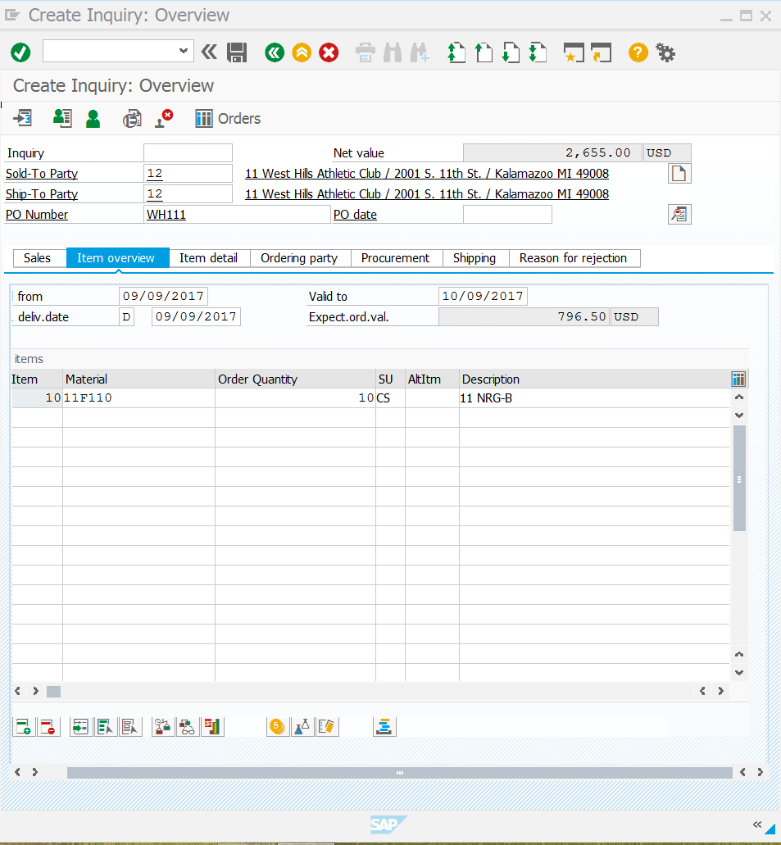

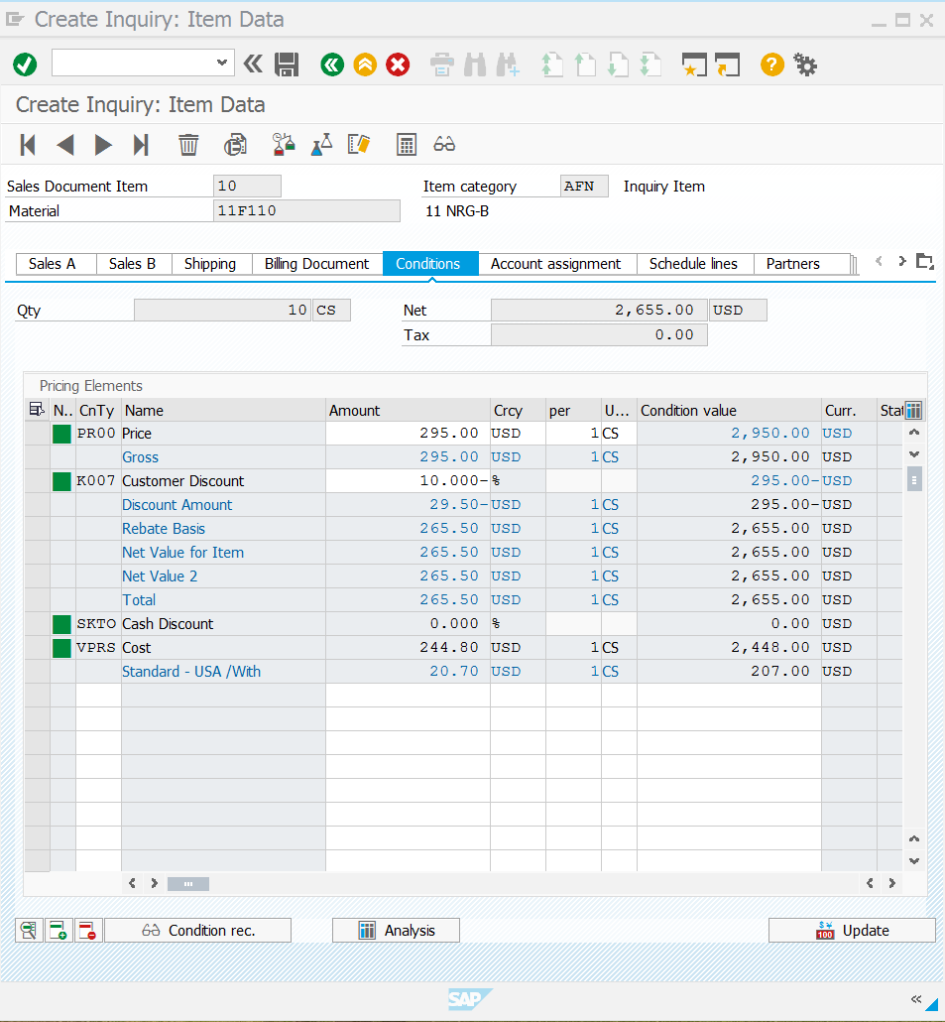

**2, Create a Sales Order from an Inquiry**

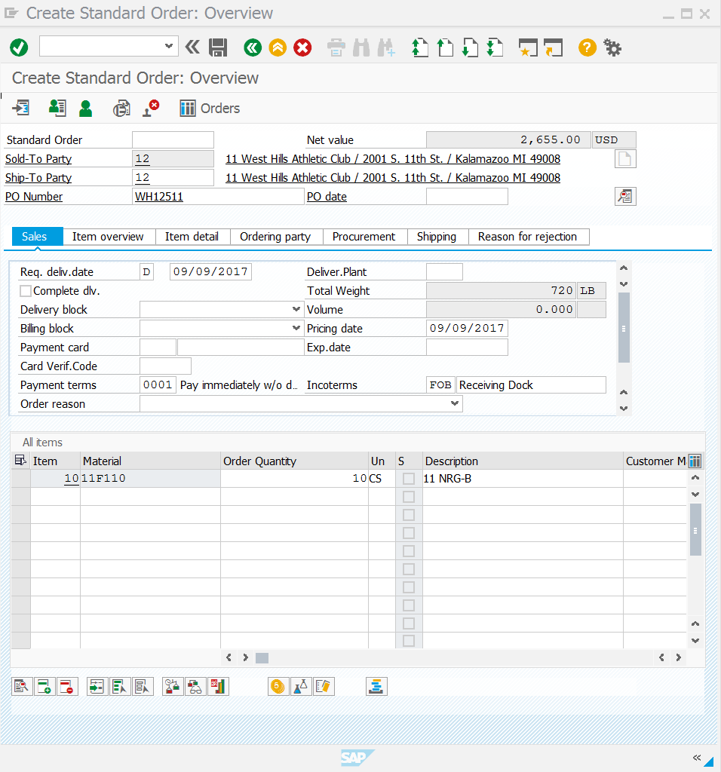

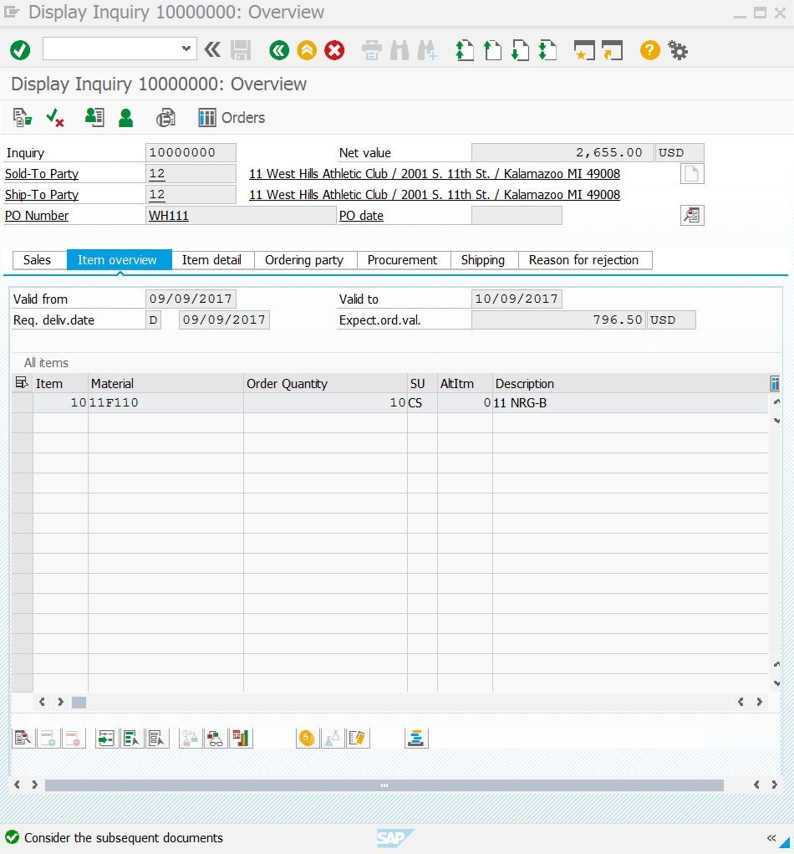

**3, Create a Delivery for the Sales Order** (not sure which 1 screenshot is correct, felt 3 will justify)

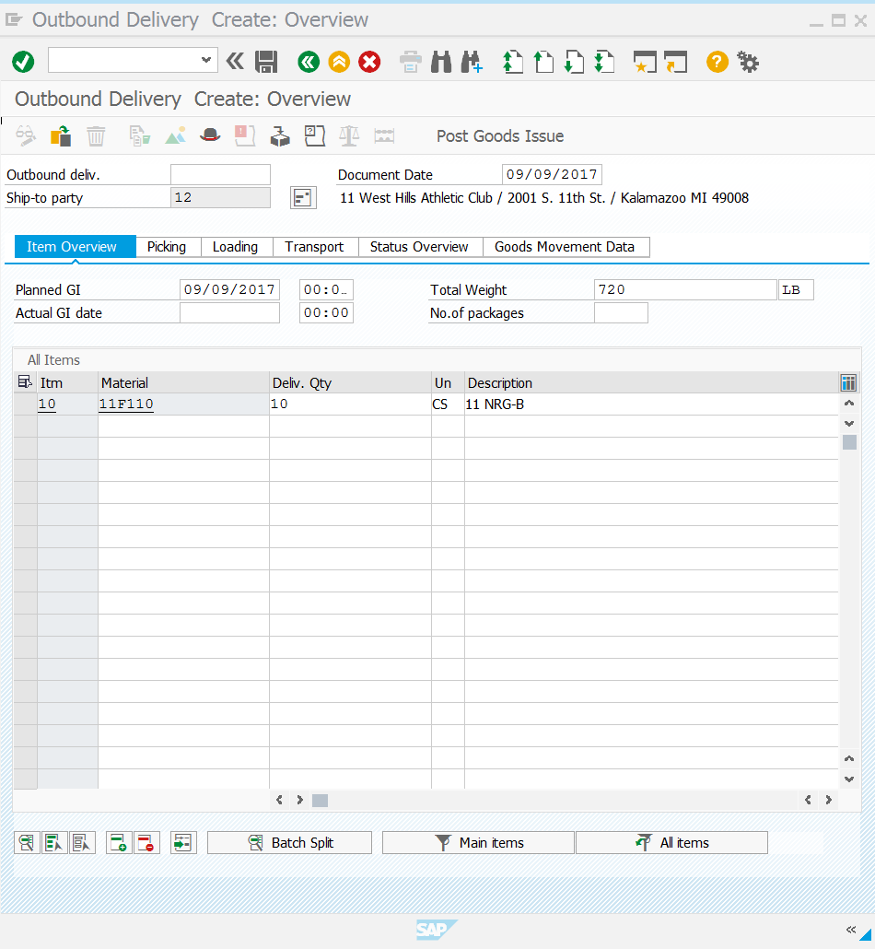

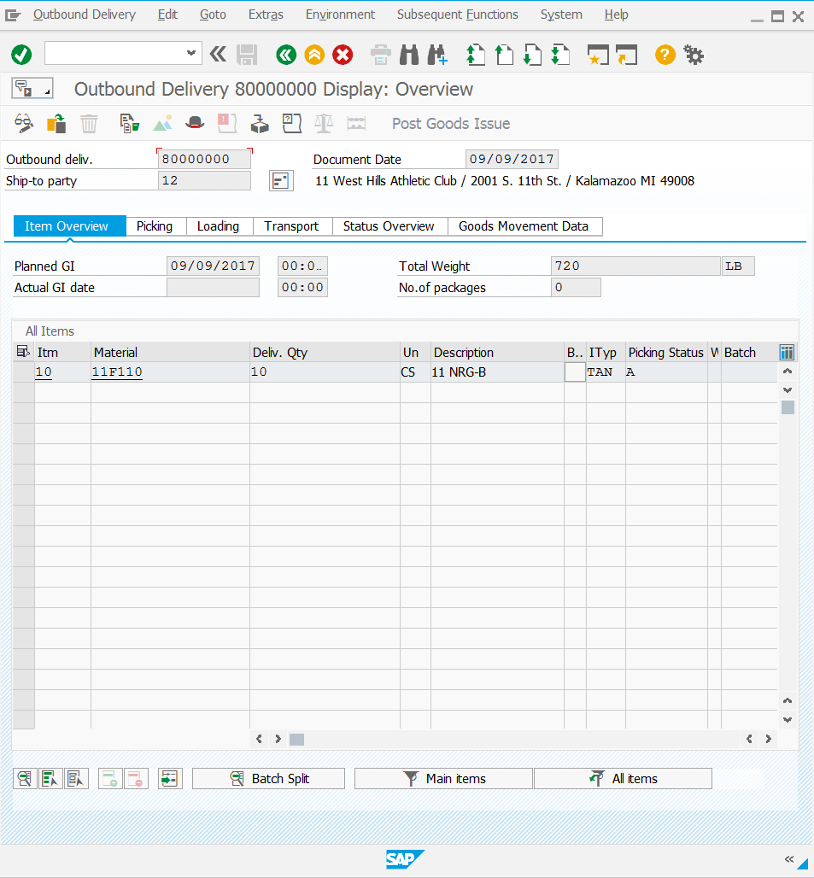

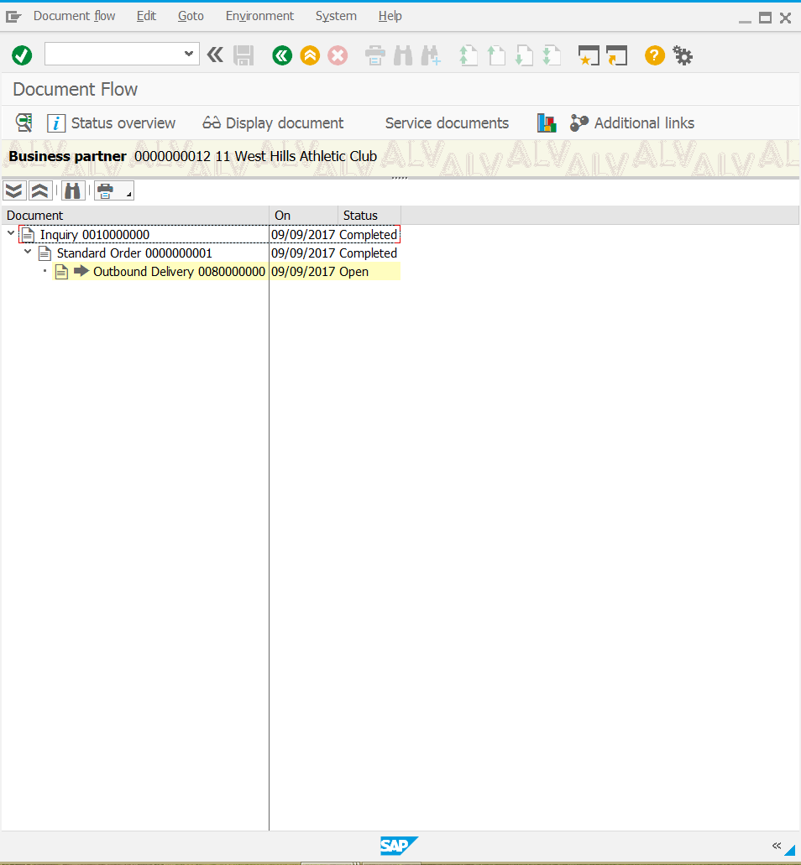

**4, Picking the order**

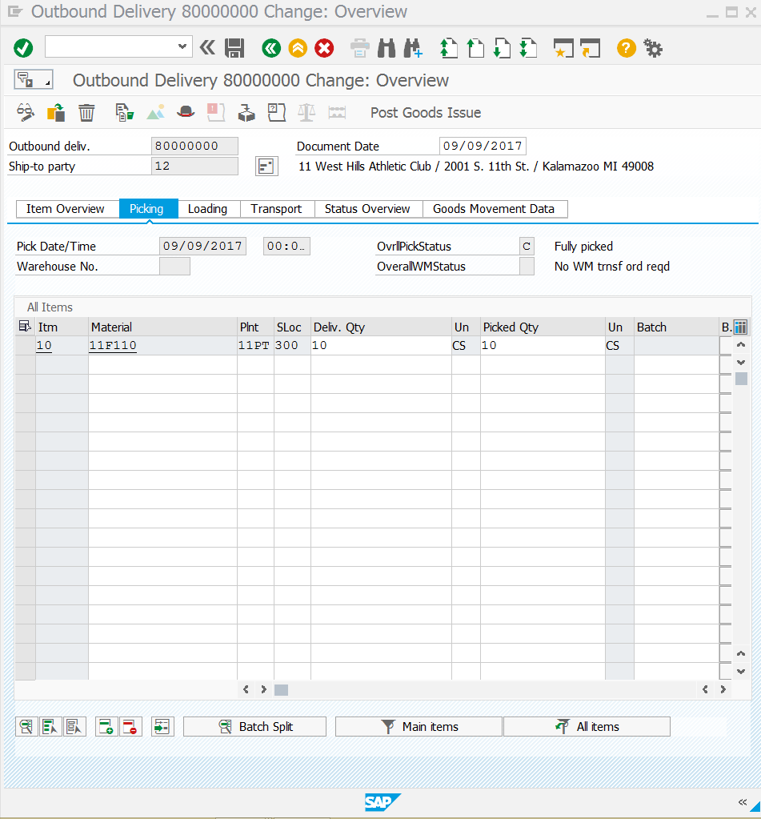

**5, Post Goods Issue**

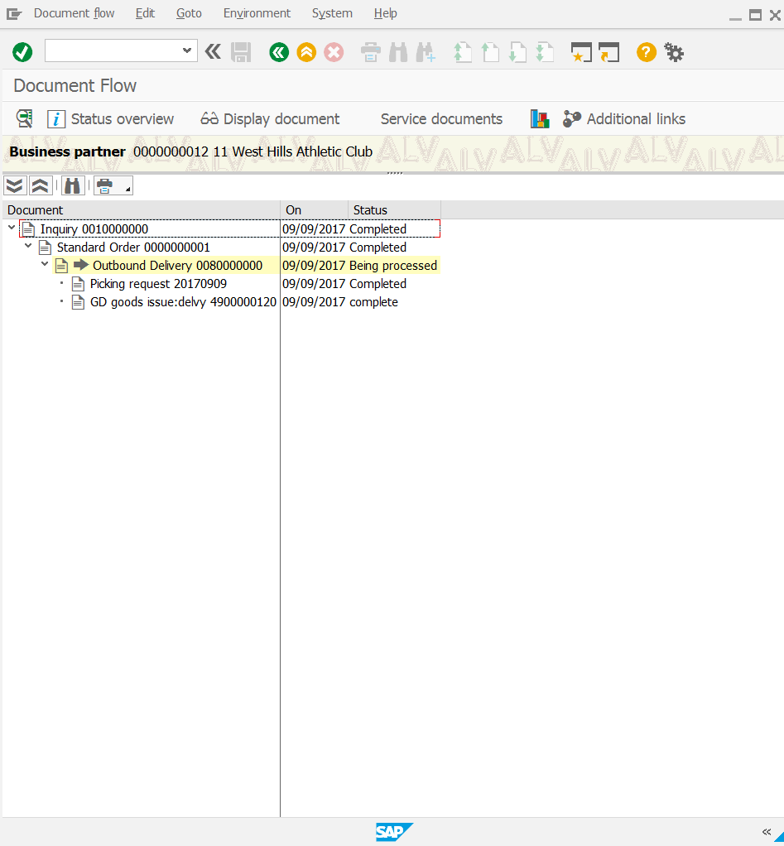

**6, Invoice the Customer**

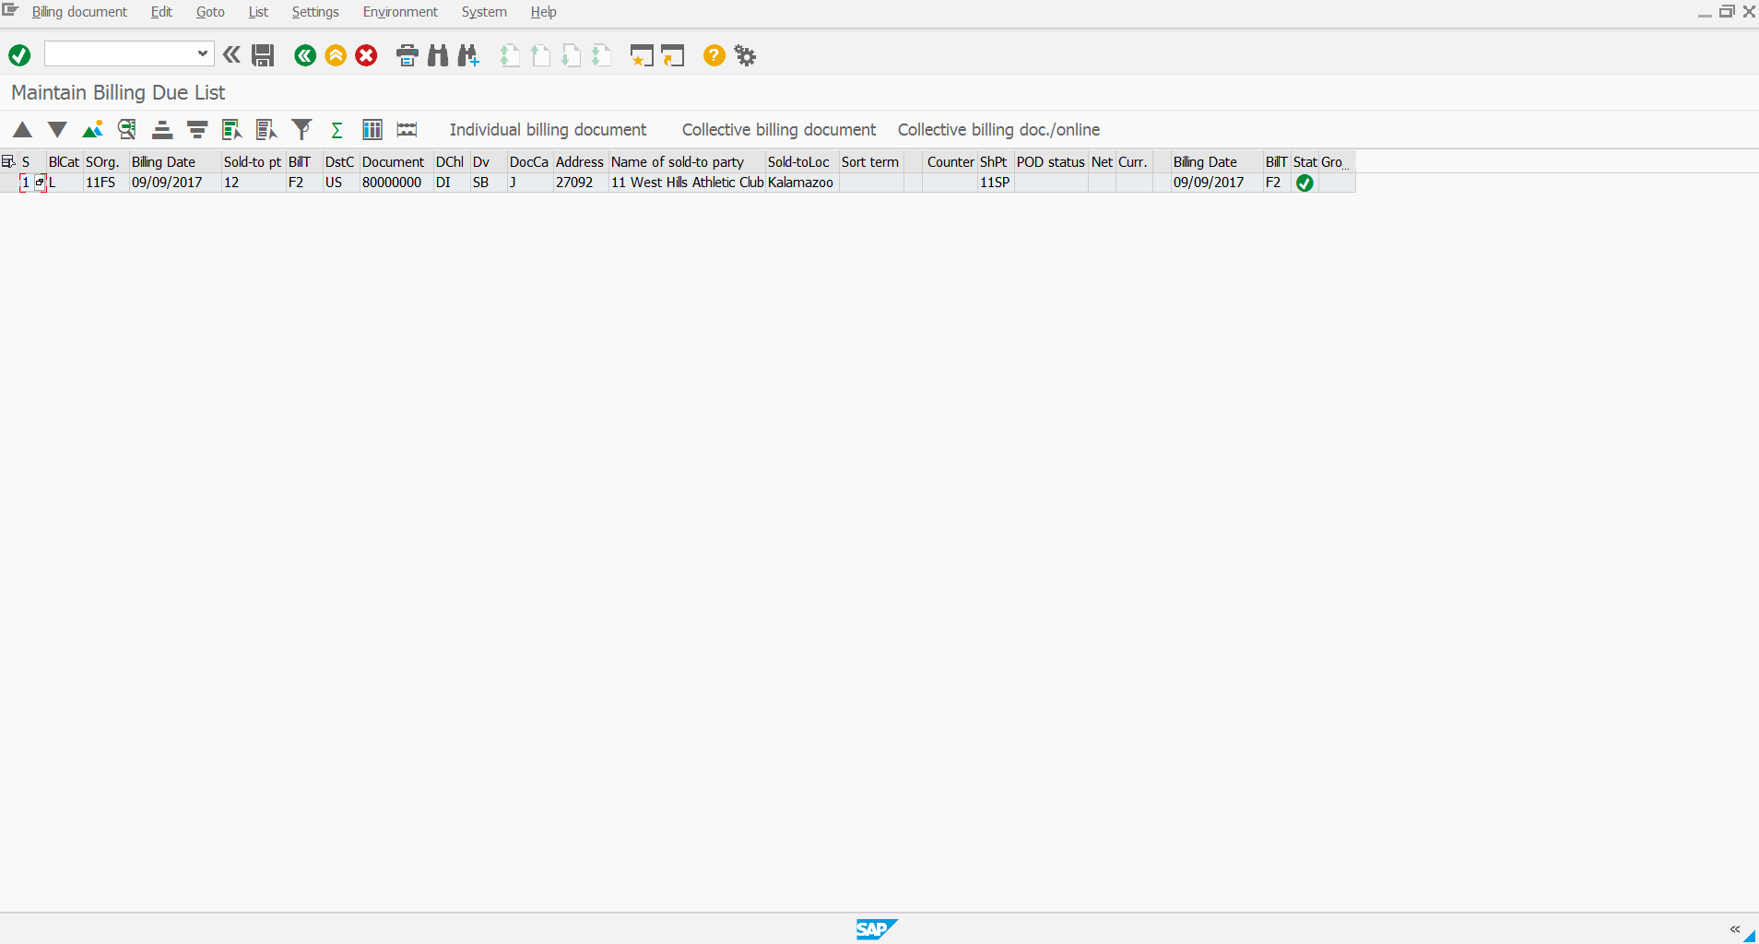

**7, Receive payment from the Customer**

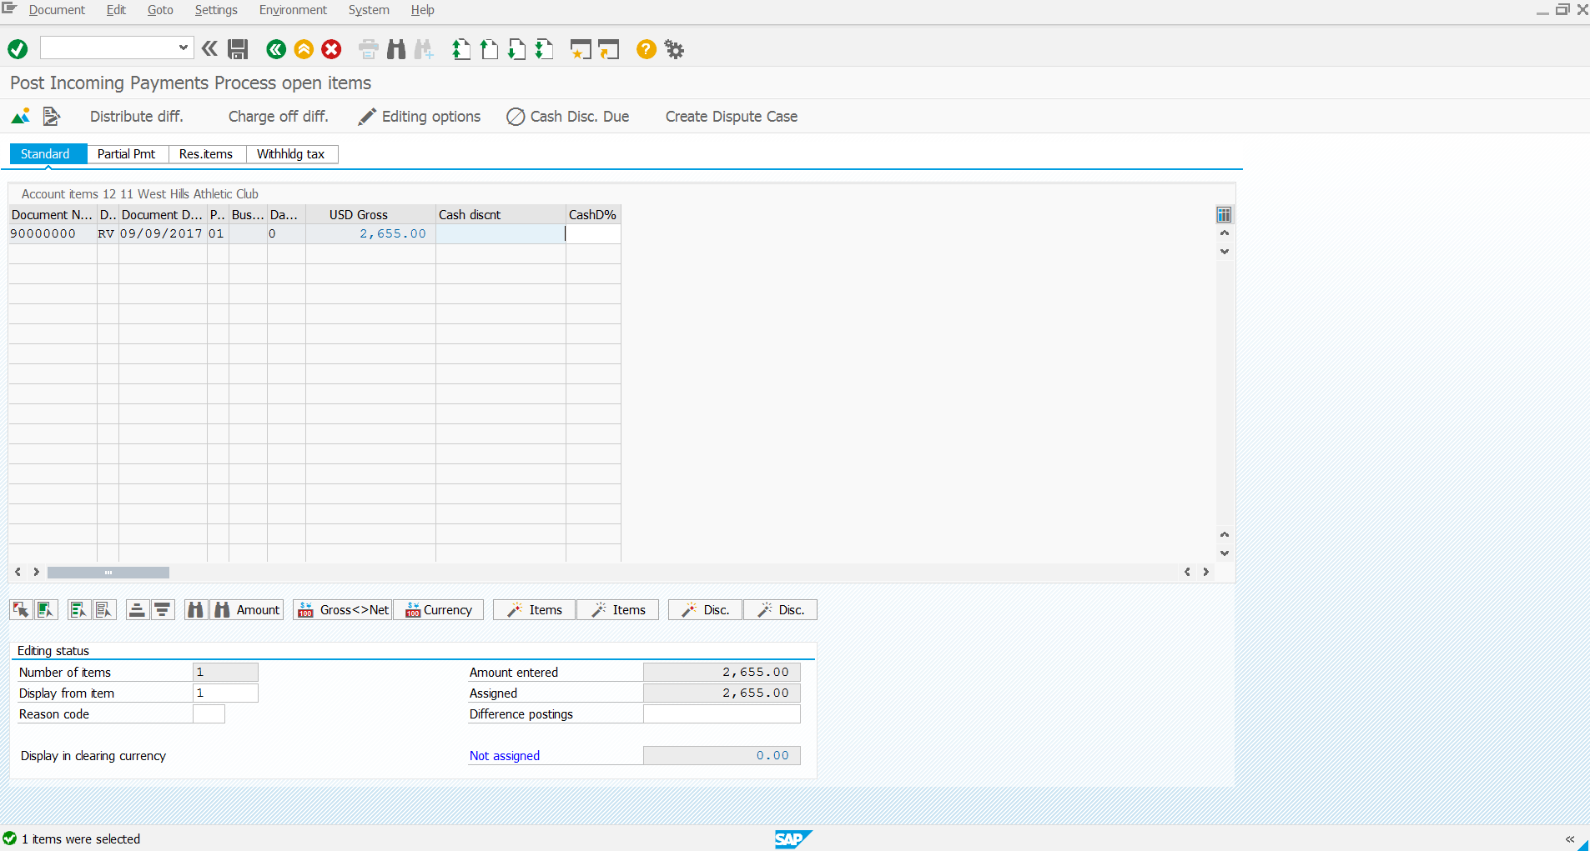

**8, Document Flow**

